Reported Bugs

**Defect 1:**

**Description:** Author field is not populating after vote has been cast.

**Steps to reproduce:**

1. Enter the “Buggy Cars Rating” application
2. Login in to the application
3. Click on Overall Rating Image Link
4. Click on Make link for Lamborghini
5. Click on Model link for Diablo
6. Enter a comment
7. Click on the Vote! Button

**Expected Behaviour:** Date, Author and the Comment field should be populated and shown after the vote has been sent.

**Actual Behaviour:** Date, Author and the Comments should be populated.

**Screenshot**

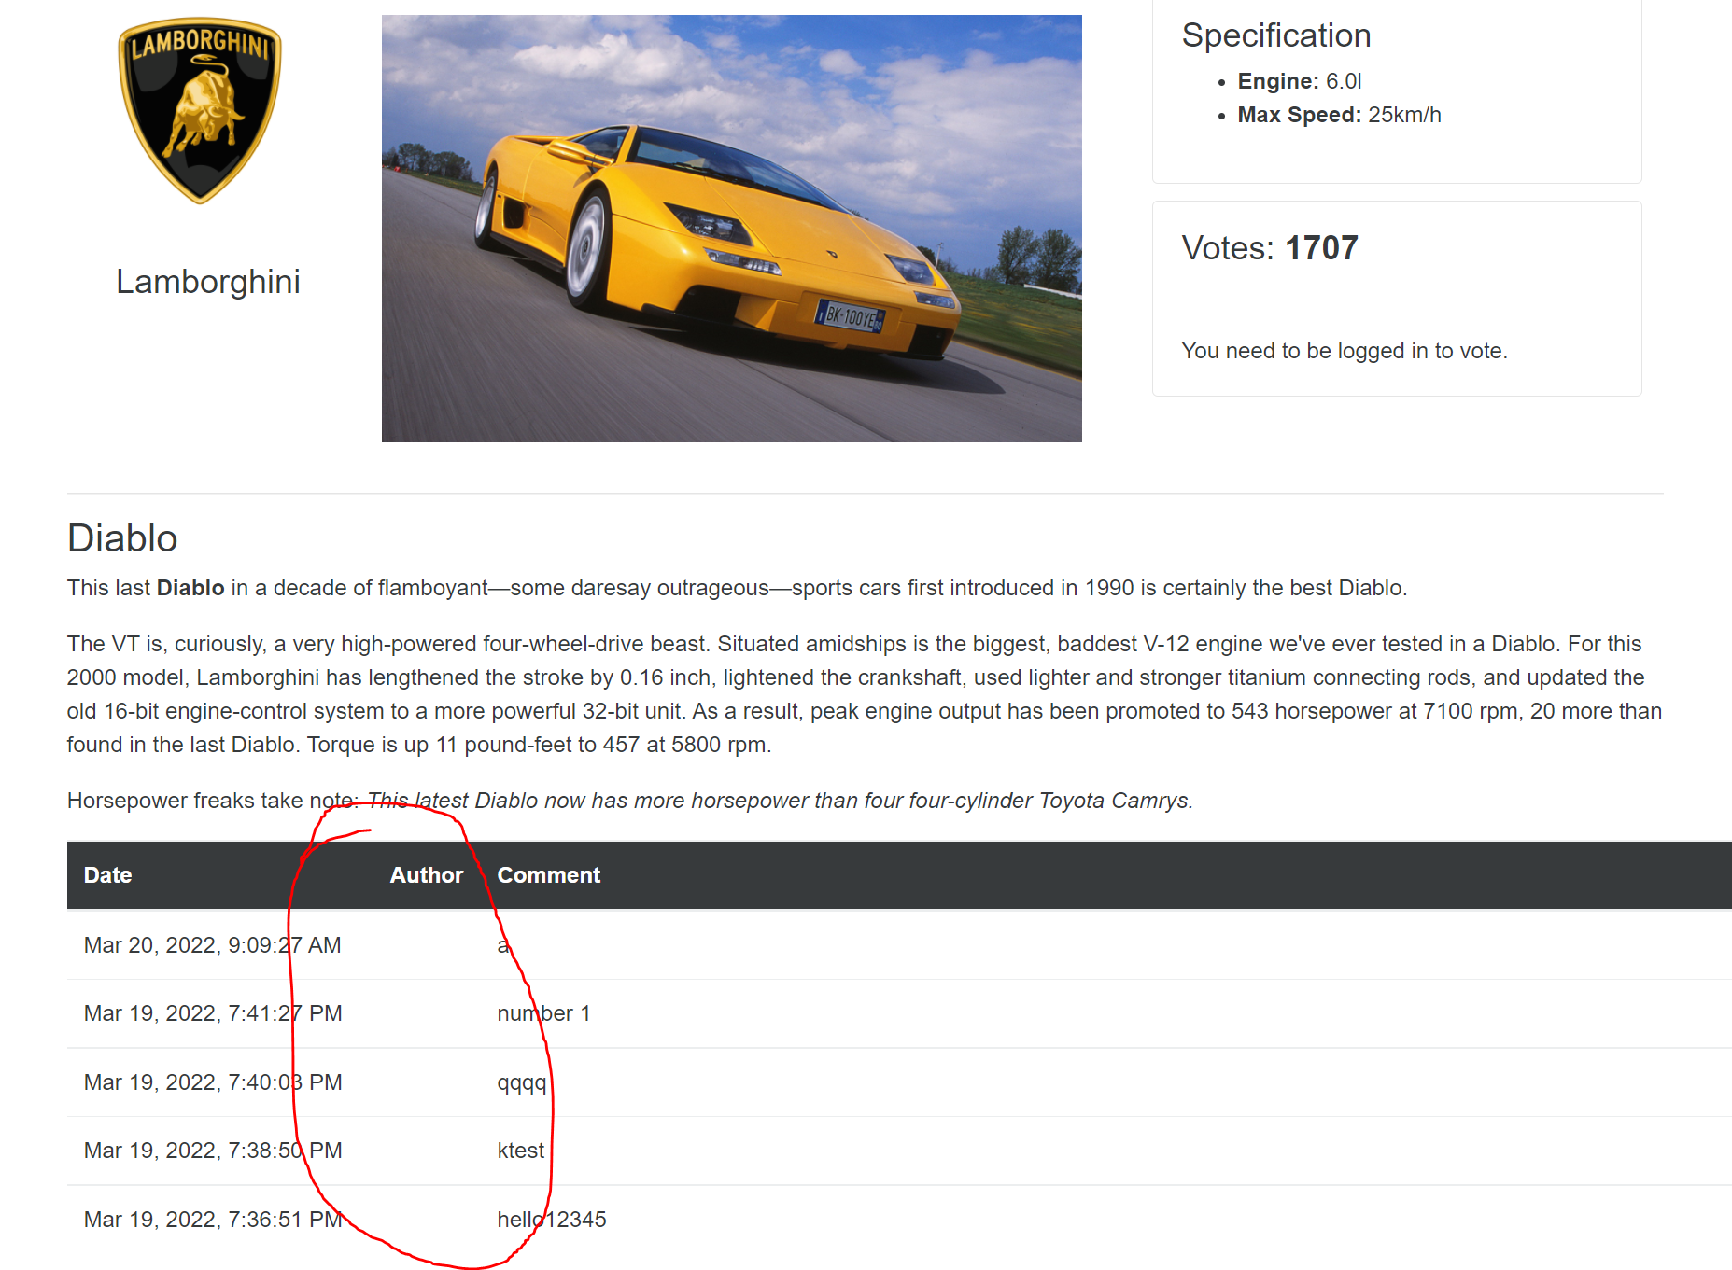

**Priority:** Medium

**Defect 2:**

**Description:** Unable to go back to homepage after clicking Buggy Ratings Logo

**Steps to reproduce:**

1. Enter the “Buggy Cars Rating” application
2. Click on Popular Make image link
3. Click on the “Buggy Cars Ratings ” logo link at the top left of the page

**Expected Behaviour:** Navigate back to the homepage.

**Actual Behaviour:** Does not navigate back to the homepage. Inspecting the page shows that the href attribute has a value of /broken.

**Screenshot**

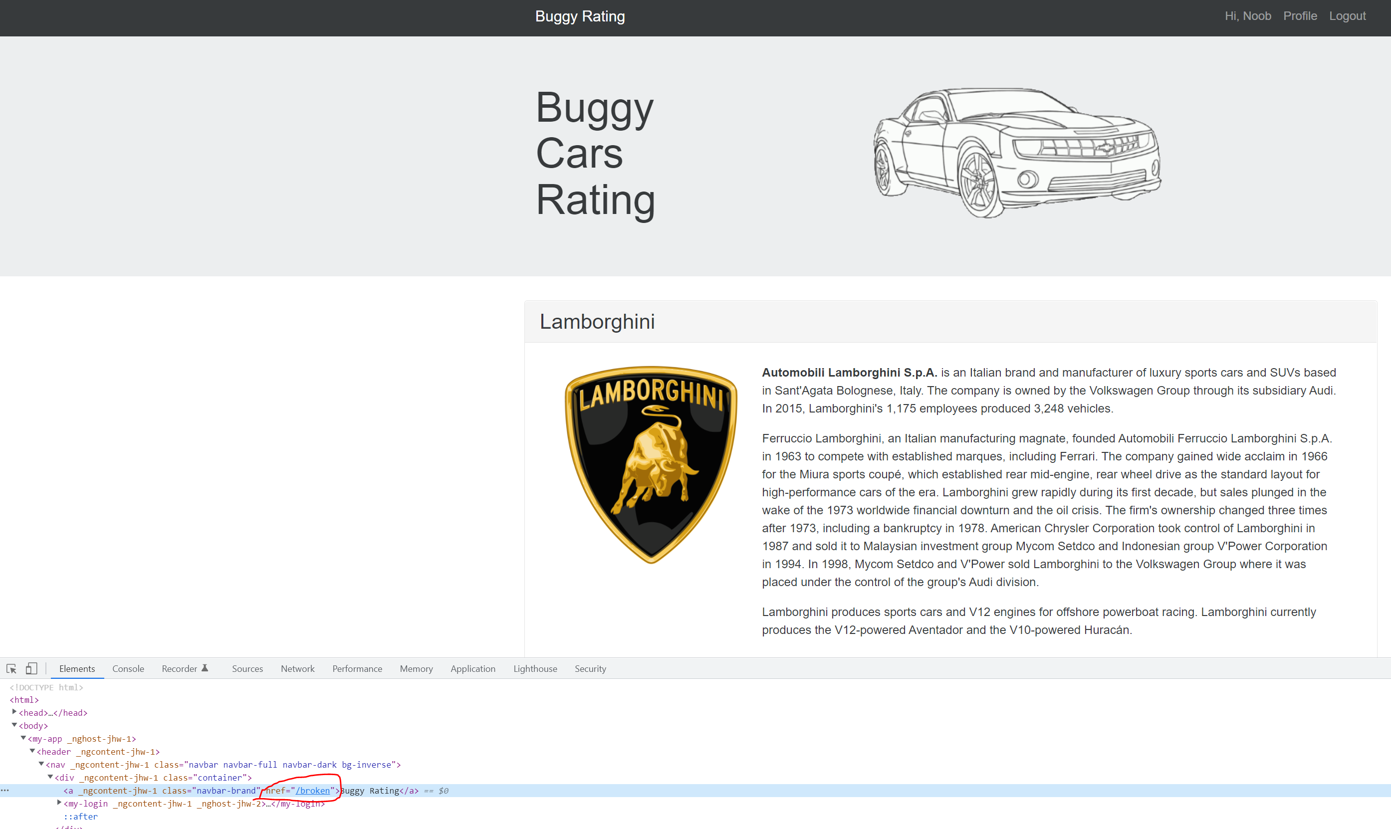

**Priority:** High

**Defect 3:**

**Description:** Application still displays personal info after logging out.

**Steps to reproduce:**

1. Enter the “Buggy Cars Rating” application
2. Login in to the application
3. Click on the “Profile” link at the top right of the page
4. Logout of the application

**Expected Behaviour:** Logging out should display another page preferably the homepage and not the profile page.

**Actual Behaviour:** After logging out the “Profile” page is still being displayed.

**Screenshot**

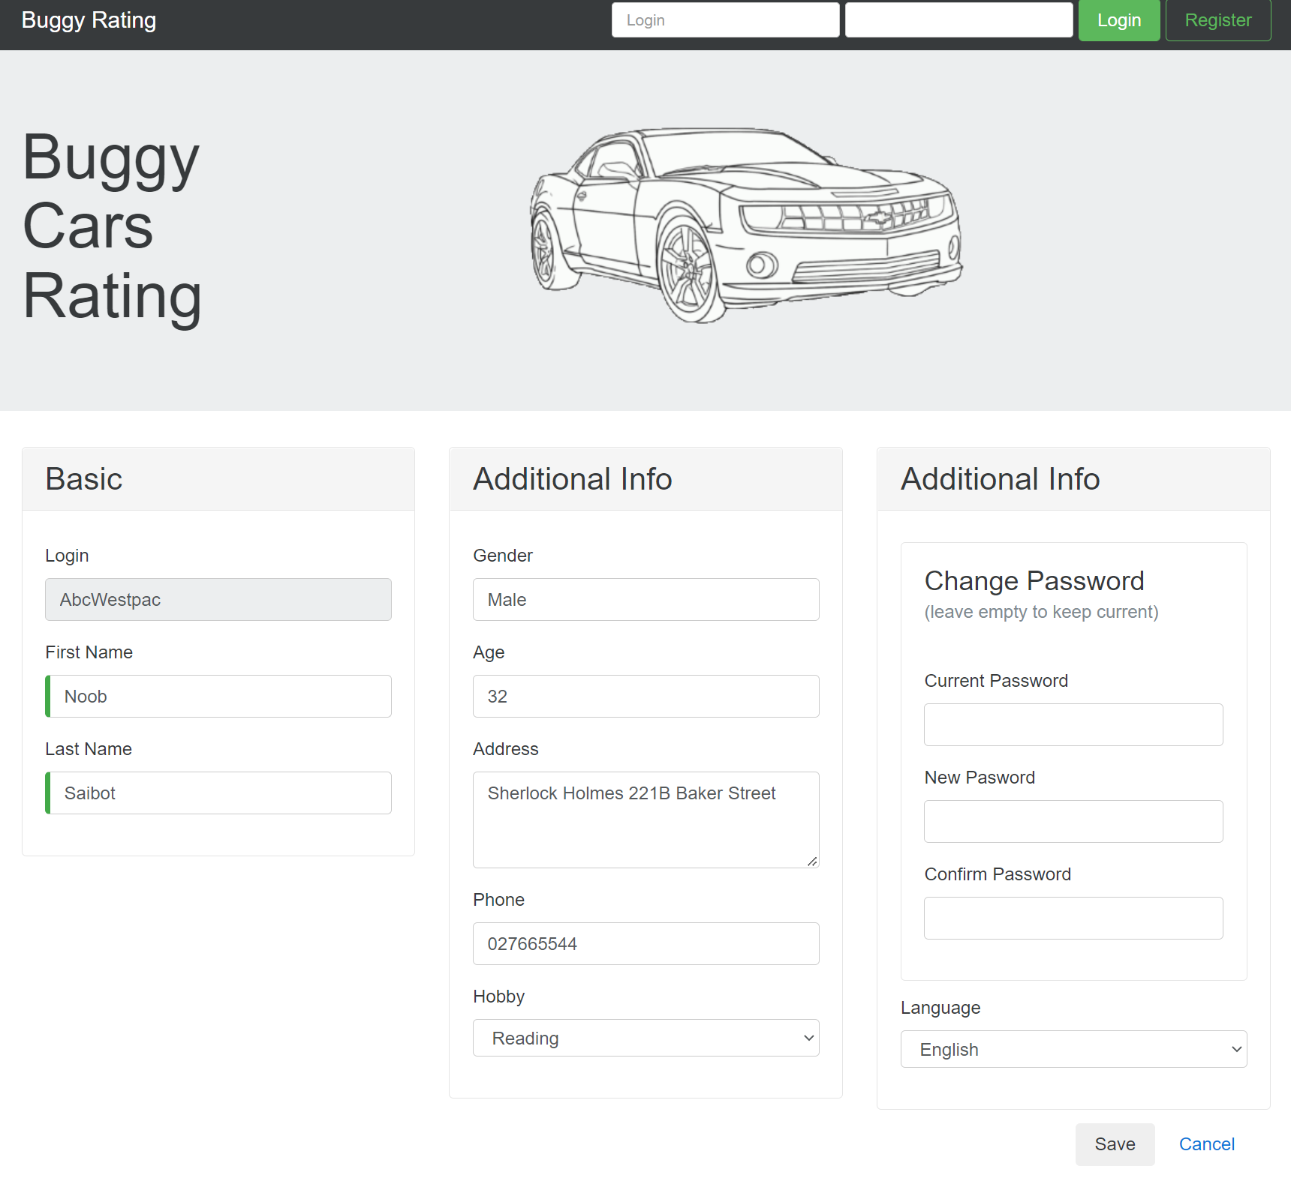

**Priority:** Critical as sensitive data is being displayed

**Defect 4:**

**Description:** Login names should be unique. Converting to lowercase and making sure the user doesn’t create an account with the same username

**Steps to reproduce:**

1. Enter the “Buggy Cars Rating” application
2. Click the Register link
3. Provide all the required details and enter “Noob” in the login field
4. Repeat the steps again and register again with the username “noob” in the login field.

**Expected Behaviour:** The application should not allow duplicate registrations to happen.

**Actual Behaviour:** The application allows a registration to happen with taking into account the case sensitivity.

**Screenshot**

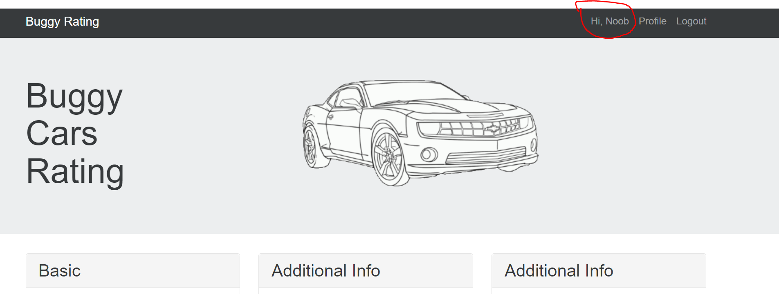

**Priority:** Critical as username should be unique

**Defect 5:**

**Description:** Broken image for the Lancia Ypsilon model car

**Steps to reproduce:**

1. Enter the “Buggy Cars Rating” application
2. Click on the “Overall Rating” link
3. Navigate to the page that displays the make Lancia and the model Ypsilon

**Expected Behaviour:** Image should display.

**Actual Behaviour:** Broken image. The image should display on the page

**Screenshot**

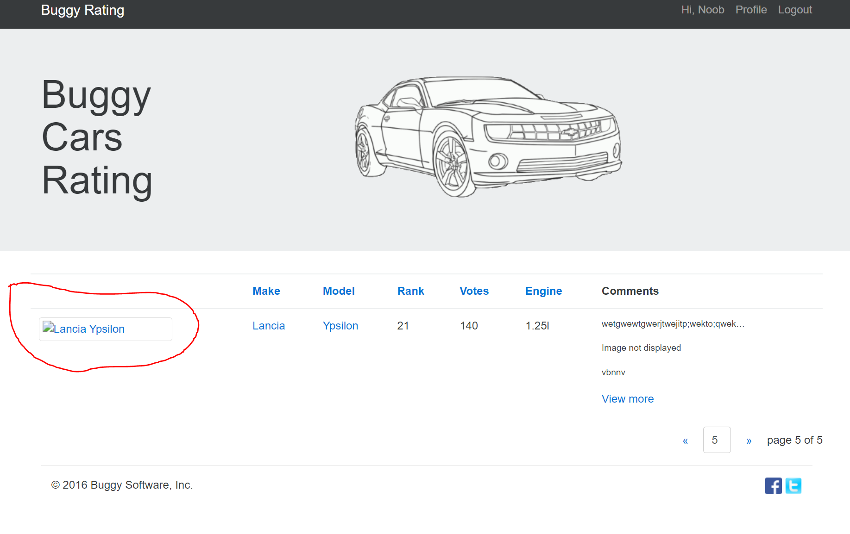

**Priority:** Medium

**Defect 6:**

**Description:** Unable to go visit the twitter page of “Buggy Cars Rating”

**Steps to reproduce:**

1. Enter the “Buggy Cars Rating” application
2. Click on “Overall Ratings” image link
3. Click on the twitter icon logo link at the bottom right of the footer

**Expected Behaviour:** Navigate back to the twitter account of “Buggy Cars Rating”

**Actual Behaviour:** Does not navigate back to the twitter account of Buggy Cars Rating. Inspecting the page shows that the href attribute has a value of https://www.twitter-broken.com/.

**Screenshot**

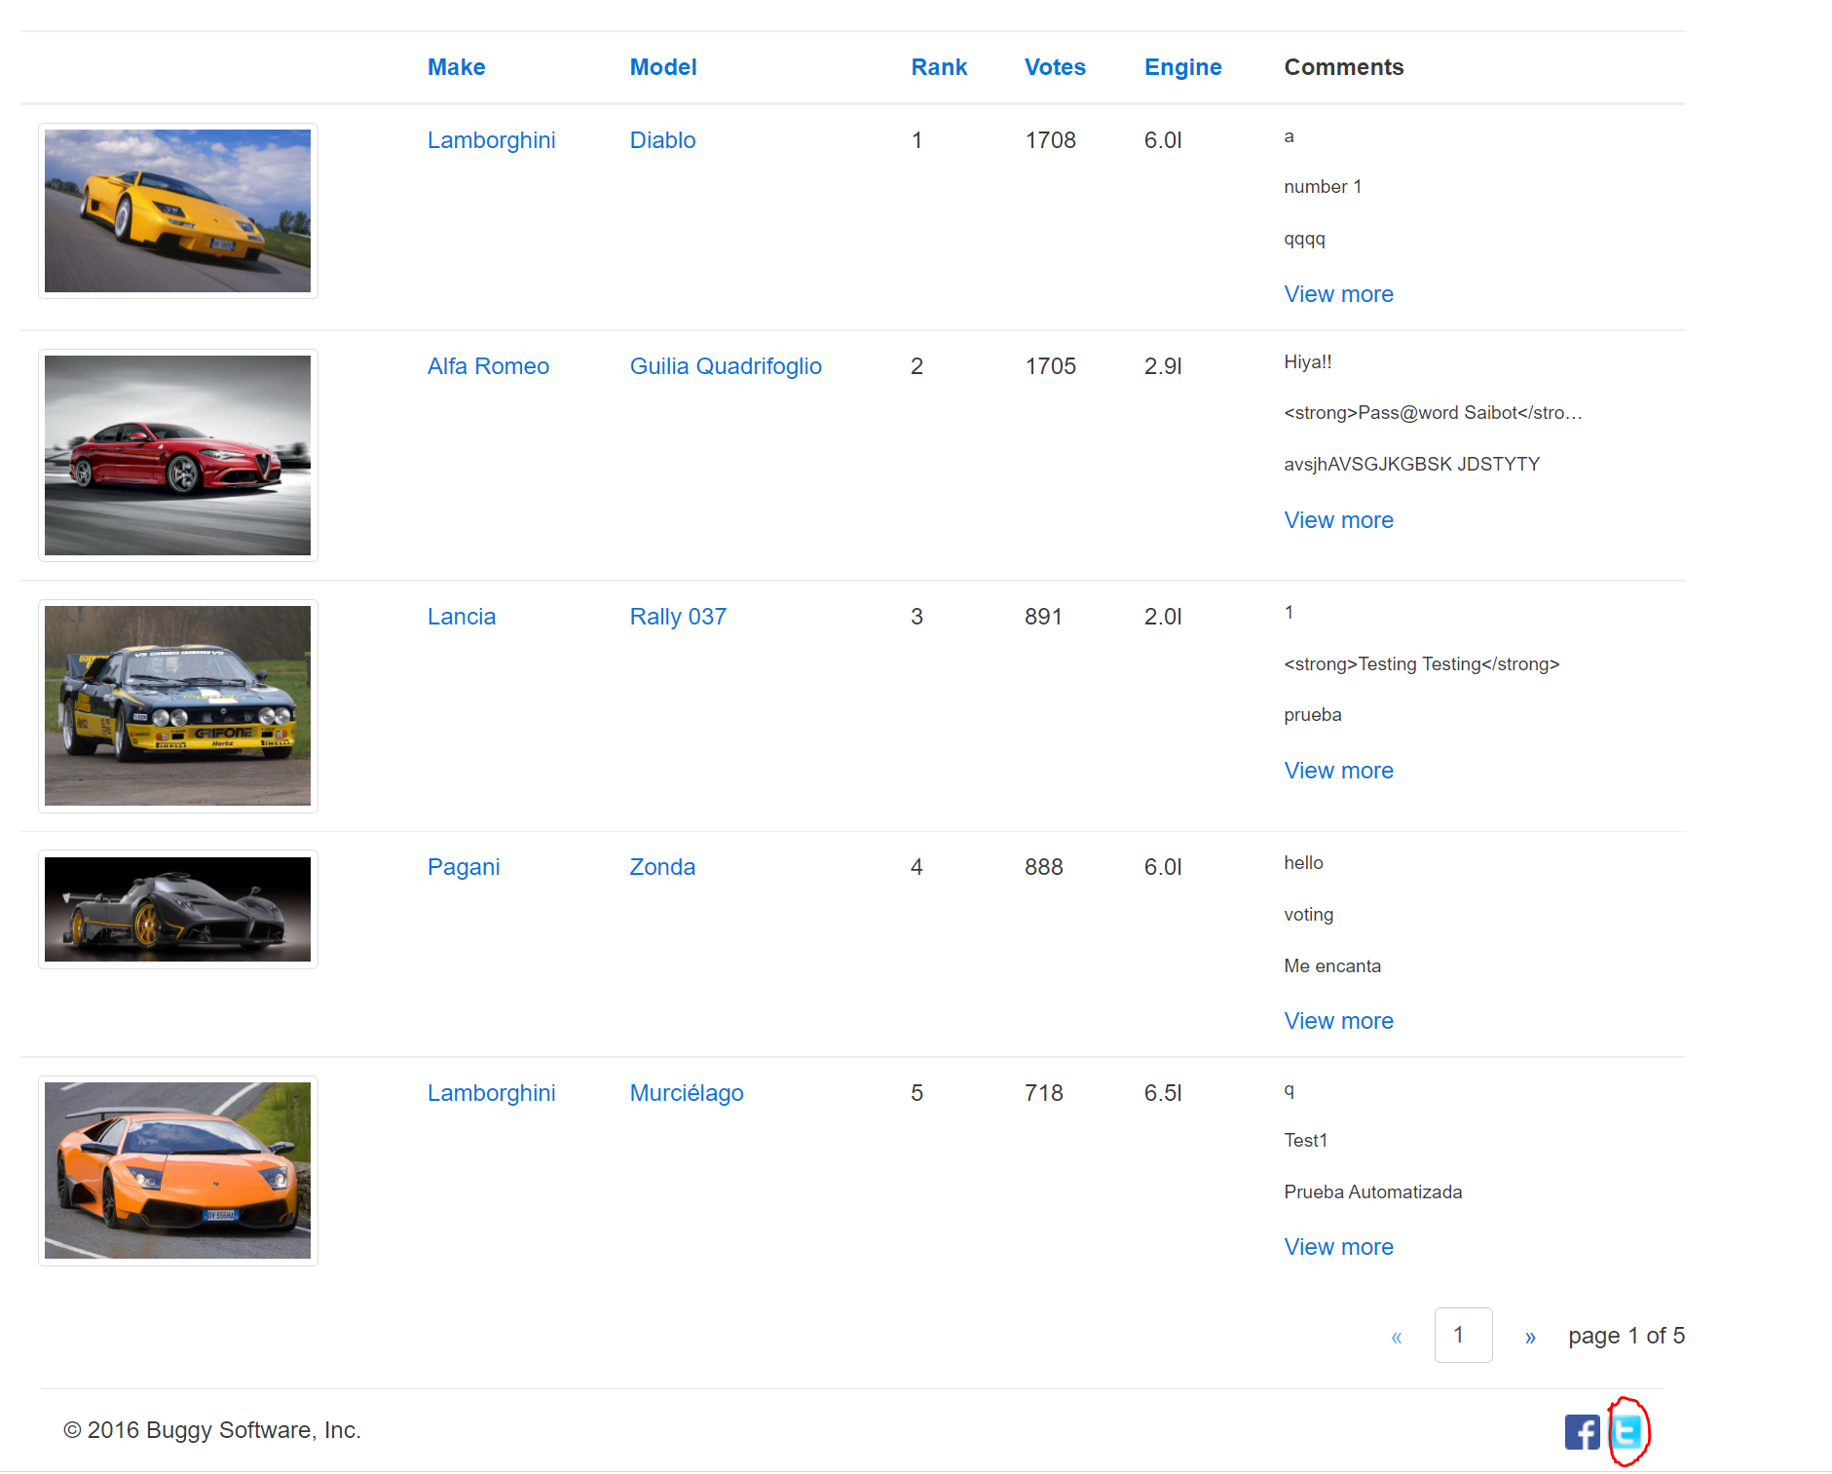

**Priority:** Medium